長庚大學資訊工程學系一百零六學年度上學期計算機圖學課程期中考試題
上課班級: 三年甲班 授課老師: 林俊淵
受測範圍: Slides 1~6

- Please write an OpenGL program to draw the picture. (Total: 70 points)
- 20 points   |  | - 20 points  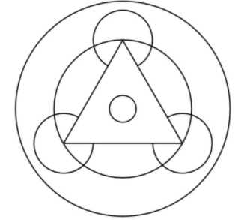
- 30 points

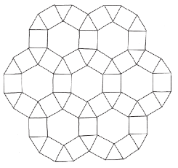

- Please write an OpenGL program to draw the picture. (Total: 30 points)
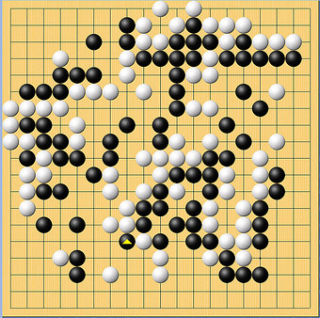  (example) | - Create a windows with a size of 600x600.  - Display a GO board with 18x18 boxes. Each box with a size of 30x30.  - Random generate 80 GO white and 80 GO black, each white/black with a size of 30x30. (fall at the intersection of lines)

完成全部作答後，請舉手由老師下去評分。
請記得儲存檔案，請將全部檔案壓縮成【學號.rar】然後上傳到ftp上.

